**P3 – Design an object oriented application to meet defined requirements**

**Introduction**

In this report, I will design the application. There will be four forms that I will design.

**Login Screen**

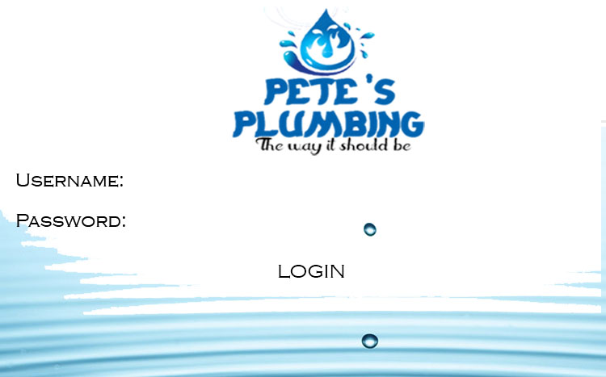

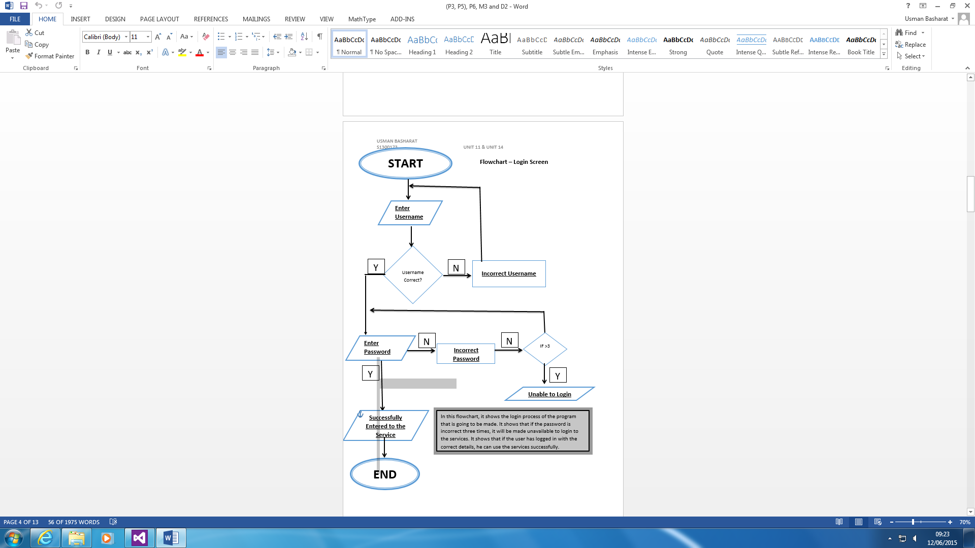The first thing that the user will do is these details. No other screen will appear until the user has entered these details. This is how the login screen will roughly look like, when it has been complete. The main aim of the login screen is for security purposes. Firstly, the user will need to insert his username for him to login and erase any errors for it to be done. Any incorrect password will not allow the user to go to the main form. The button is there for the user to be referred to the main form. The background is specific wallpaper that goes with the unique logo. This unique logo was made separately.

**Main Form**

**NOTE: - LABOUR IS MEASURED IN HOURS, TRAVEL IS MEASURED IN MILES AND THE REST PIPES ARE MEASURED IN METRES**

LABOUR = £0.00

TRAVEL = £0.00

PLASTIC PIPES =£0.00

COPPER PIPES = £0.00 CHROME PIPES = £0.00

Overall Cost:

VAT at 20%

Total Cost with VAT

Discount at 5% if total> = £500

Total after discount:









HELP SHEET

CLEAR

DATABASE

CALCULATE

The Main Form works by only putting into the Textboxes how many you need. The measurements are fixed into it, so the user will not be able to change it. The calculate button calculates what has been typed into the textboxes. The restart button clears all of the numbers that has been entered and calculated. Submit button gets all of the completed calculations and converts it to an excel spreadsheet. This helps the user has he can save the submitted calculations and he cannot lose any of it. The separate section on the top-left is a rule box that helps the user. The last button is Help Sheet. This obviously helps the user. If he/she gets stuck whilst using the program, he/she can click this button for help.

**Database**

Student Information

Customer ID:

Customer Name:

Customer Last Name:

Job:

SUBMIT

PRINT

CLEAR

This is the database that is going to be replaced by the old one. All you do for this is fill in the required details and it will be submitted on to the list box shown. The idea behind this database is to use the details above and insert it within the box. To summarise what has been said about the customer. This way, it would be easier than filling it out the other way. The user can print out the summary box too.

**Help and Support**

**Help Sheet**

Each step would show you how the whole program works

**Step 1:** Enter username and password to use Pete’s plumbing password.

**Step 2:** Fill in the fields that are required

**Step 3:** Fill in the labour, then how many hours are required

**Step 4:** Enter a number for the travel. You have to fill in all of the fields, so that you can move forward

**Step 5:** Once all of the fields are complete, click the calculate button to do all the calculations.

**Step 6:** If any errors are displayed, or any missing fields, you have to go back and complete them.

**Step 7:** The grand total of it will be displayed.

**Step 8:** You will be referred to a Microsoft Excel spreadsheet, and this would be a completion of what you have entered. You can save the document.

**Any other enquires or problems with the program:**

**Email:** [help@petesplumbingservice.com](mailto:help@petesplumbingservice.com)

**Phone Number:** 0205 524 1942

This is the help service that is required, if any assistance is needed for the user. This shows a step-by-step guide for the user to get help. All of the steps that are shown, it shows each of what is going to happen throughout the program. The details below it shows that if this help is not helpful, he can contact them through email and phone number.